|  |  |
| --- | --- |
| *school-learn-study-hat-graduate-512.png* | ***Study*** |

Answer the following questions:

1. What is Boolean? Write down 3 different expression that results a Boolean type (i.e. 5 == 6)

* Booleans are a data type commonly used in programming languages. By definition, a *boolean* only has two possible values: true or false.
* 3 expression:
* X%5 == 0
* X === n
* Ans === “c”

1. What is a flow chart? Draw flow chart for the following code snippet: (you can draw on a paper, take a picture of it)

if name == “Huy be":

print(“Hand some")

elif name == “Huy big":

even\_more\_handsome = True

else:

webbrowser.open(“<https://www.youtube.com/watch?v=04854XqcfCY>”)

* A **flowchart** is a type of diagram that represents a workflow or process
* 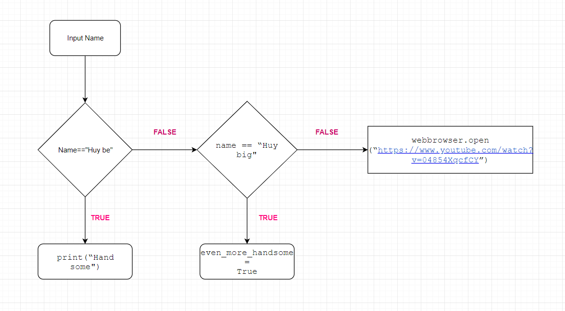

1. What is nested conditionals? Write a piece of code that uses nested conditionals

* *Placing If Statement inside another IF Statement is called JavaScript Nested If Statement*
* *If ( a == b){*

*If ( b==c){*

*Console.log(“All are equal”);}*

*Else {*

*Console.log(“a&b are equals”);}*

*}*

*Else{}*

|  |  |
| --- | --- |
| *http://www.bestappsforkids.com/wp-content/uploads/2012/04/save-turtle.png* | ***Turtle exercises*** |

Using turtle to draw the following shapes:

|  |  |
| --- | --- |
| Screen Shot 2015-12-25 at 04.41.55.png | 2.  Hi-CBUEkYGb-DOPBqc1p-_os3fG83P3OxHLgEhilkO4 |
|  |  |

1: <https://turtle-js.herokuapp.com/?turtle=hilH51dWcb>

2: <https://turtle-js.herokuapp.com/?turtle=2pZ78O20Lq>

|  |  |
| --- | --- |
| *6iporAnbT.jpg* | ***Serious exercises*** |

1. Write a program that asks user their height (cm) and weight (kg), and then calculate their BMI (Body Mass Index):

BMI = mass (kg) / (height(m) x height(m) )

Note: you must do the conversion from cm to m before calculation

Then based on the BMI, tell them that they are:

* Severely underweight if BMI < 16
* Underweight if BMI is between 16 and 18.5
* Normal if BMI is between 18.5 and 25
* Overweight if BMI is between 25 and 30
* Obese if BMI is more than 30

1. Write a program that asks users enter a number and then calculates factorial of n: (1 \* 2 \* 3 \*... \*n)

|  |  |
| --- | --- |
| system_config_boot.png | ***Tools preparation*** |

Watch the homework submission tutorial